|  |  |
| --- | --- |
| **Practicum Case** |  |
| COMP6799 | COMP6799001 | COMP6799016 | COMP6799049  Database Technology |
| **Computer Science** | **E231-COMP6799-HG01-02** |
| ***Valid on*** *Even Semester Year 2022/2023* | **Revision 00** |

## Learning Outcomes

* LO2 – explain the concepts of relational algebra, DDL, DML, transaction management on database and concurrency control

## Topic

* Session 02 – Simple Query I

## Sub Topics

* Conditional Query
* String Functions
* Date Functions

**Tabel Relasional**

*Relational Table*

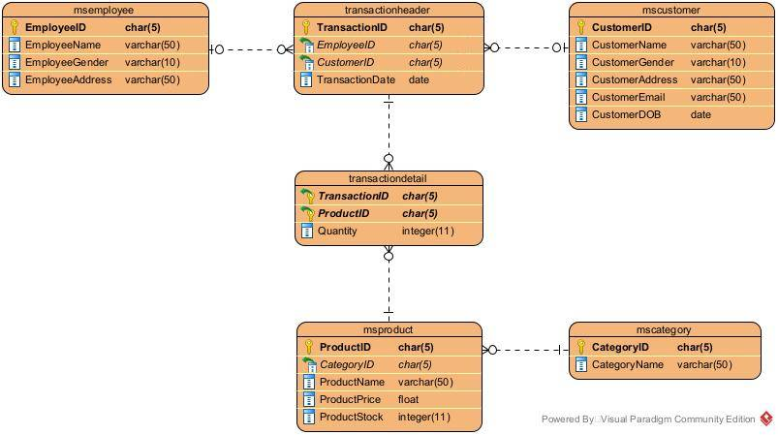

## Soal

*Case*

1. Display **all** **data** from **MsCategory** for every **category** which **name** **contains letter** ‘**a**’.

(**LIKE**)

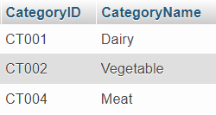

1. Display **CustomerName** (obtained by **adding** ‘**Mr.**’ before the customer name), **CustomerGender**, and **CustomerAddress** for every ‘**Male**’ **customer**.

(**CONCAT**, **LIKE**)

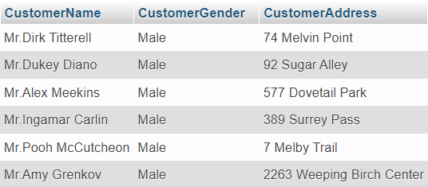

1. Display **Transaction Number** (obtained by **replacing** ‘**TR**’ with ‘**Transaction** ’ in **TransactionID**), **CustomerID**, and **TransactionID** for every **transaction** that **occur** in **range of 31 year before January 31st, 2023**.

(**REPLACE**, **DATE_SUB**)

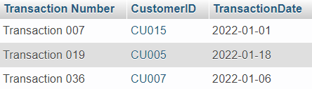

1. Display **ProductName** and **Announcement** (obtained by **adding** ‘**Price: $**’ before the product price which is **discounted by** **50%**, then add ‘ **just for today!**’ after the discounted price) for every **product** which **name ends with** ‘**Cheese**’.

(**CONCAT**, **ROUND**, **LIKE**)

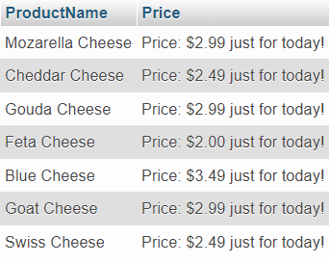

1. Display **CustomerName** and **AddressType** (obtained from the **last word** in **CustomerAddress**) for every **Female** **customer**.

(**RIGHT**, **POSITION**, **REVERSE**, **LIKE**)

.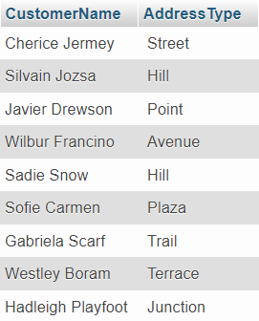

1. Display **TransactionID**, **Day** (obtained from the **day name** of the **transaction**), **CustomerName** (obtained from **CustomersName** in **uppercase** format), and **Email** (obtained by **changing** the **characters** **after** ‘**@**’ with ‘**gmail.com**’) for every **transaction** that **happen** **on** **November** and is **done by a customer** which **name is** **shorter than 12 characters long**.

(**DAYNAME**, **UPPER**, **INSERT**, **POSITION**, **REVERSE**, **LENGTH, MONTH**)

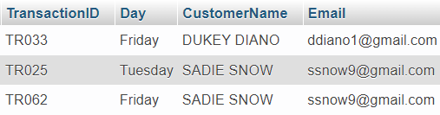

1. Display **TransactionID**, **Product Bought** (obtained by **displaying** **all** of the **product name bought** in the transaction **separated by comma**), **Date** (obtatined from **transaction date** in **dd-MM-yyyy format**) for every **transaction** thay **happens in August** and have an **odd day.**

(**GROUP_CONCAT**, **DATE_FORMAT**, **MONTH**, **DAY**)

